Connor-Francis McGrath

216869133

**Project 2**

The reference I used for my project was a 10 second long clip from a performance by the a-cappella band Voiceplay (from 5:02 to 5:12). More specifically I used the singer in the front, Tony Wakim, as my reference.

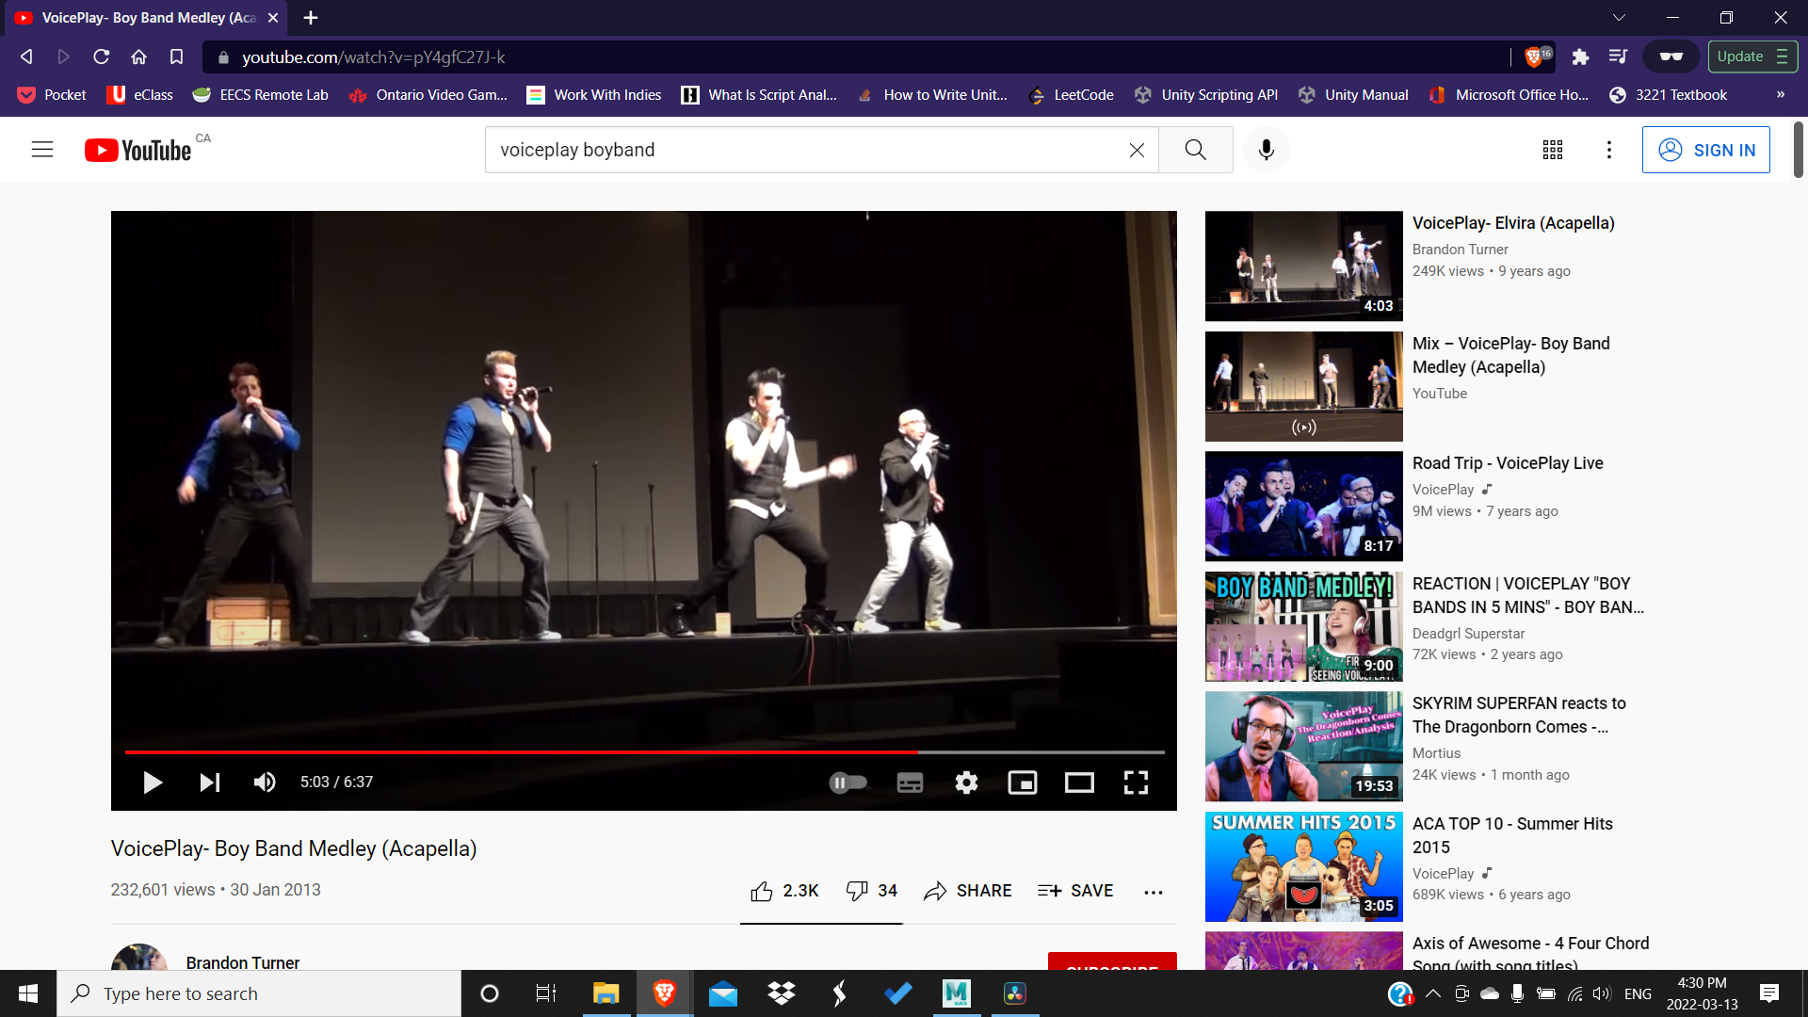

“VoicePlay- Boy Band Medley (Acapella).” YouTube, uploaded by Brandon Turner, 30 Jan. 2013, <https://www.youtube.com/watch?v=pY4gfC27J-k>.

Before I started animating I needed a rig. I used the rig I created in tutorial 6 with HumanIK.

Before I binded the rig to the mesh I needed to make sure that none of the joints were sticking out of the body. I was able to do this by selecting the rig in the outliner and seeing if I could see any highlighted joints. When I couldn’t anymore, I knew I was ready to bind it.

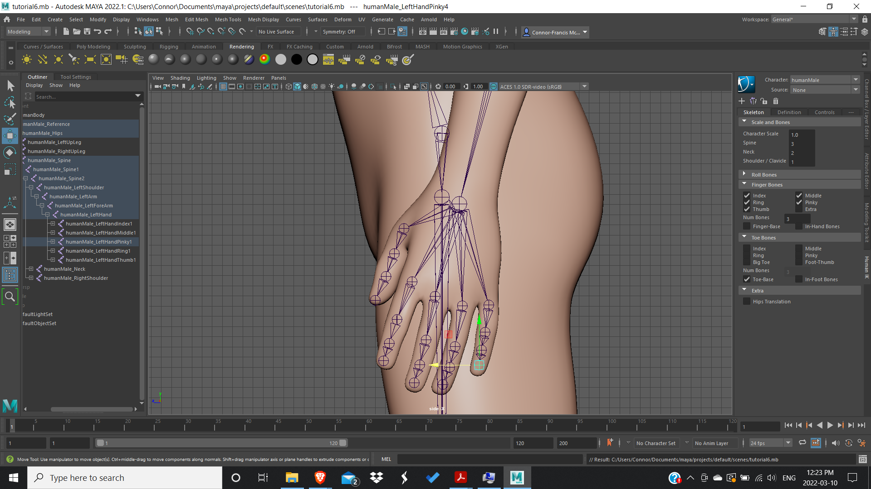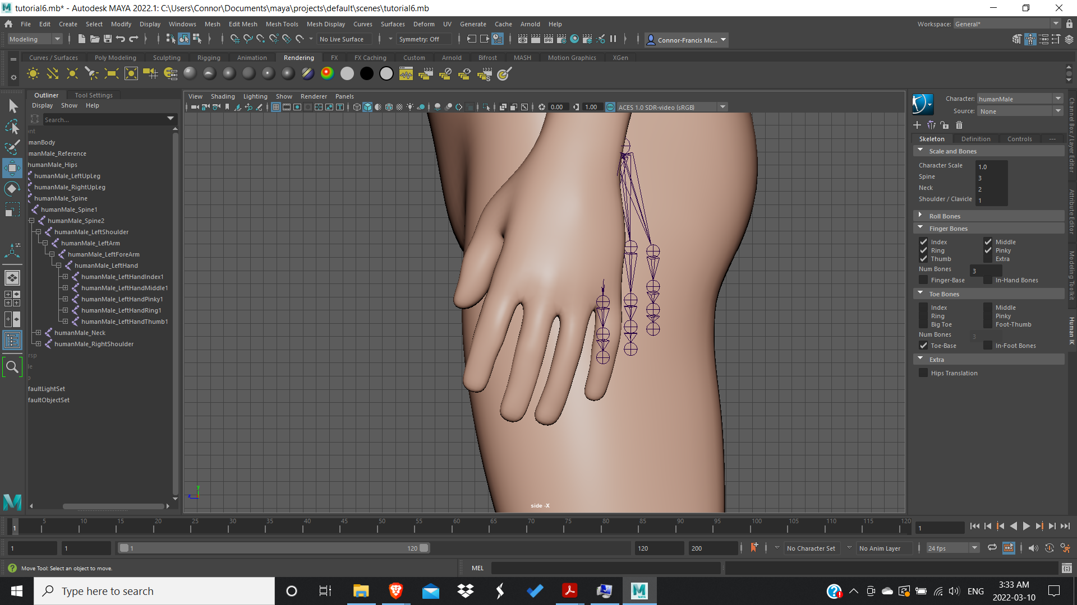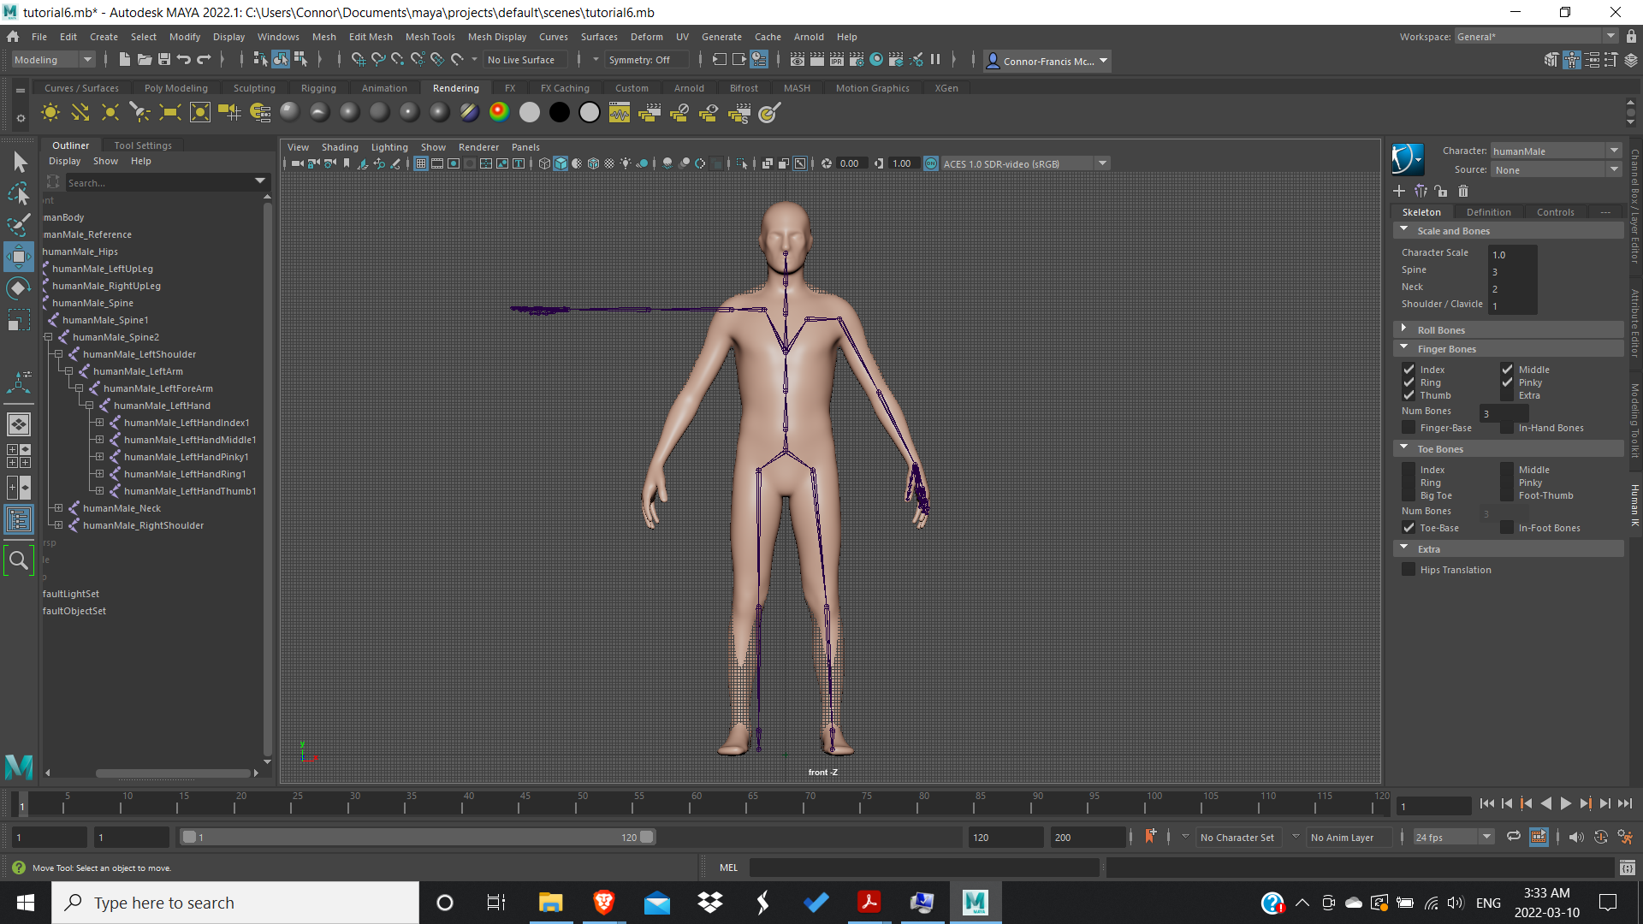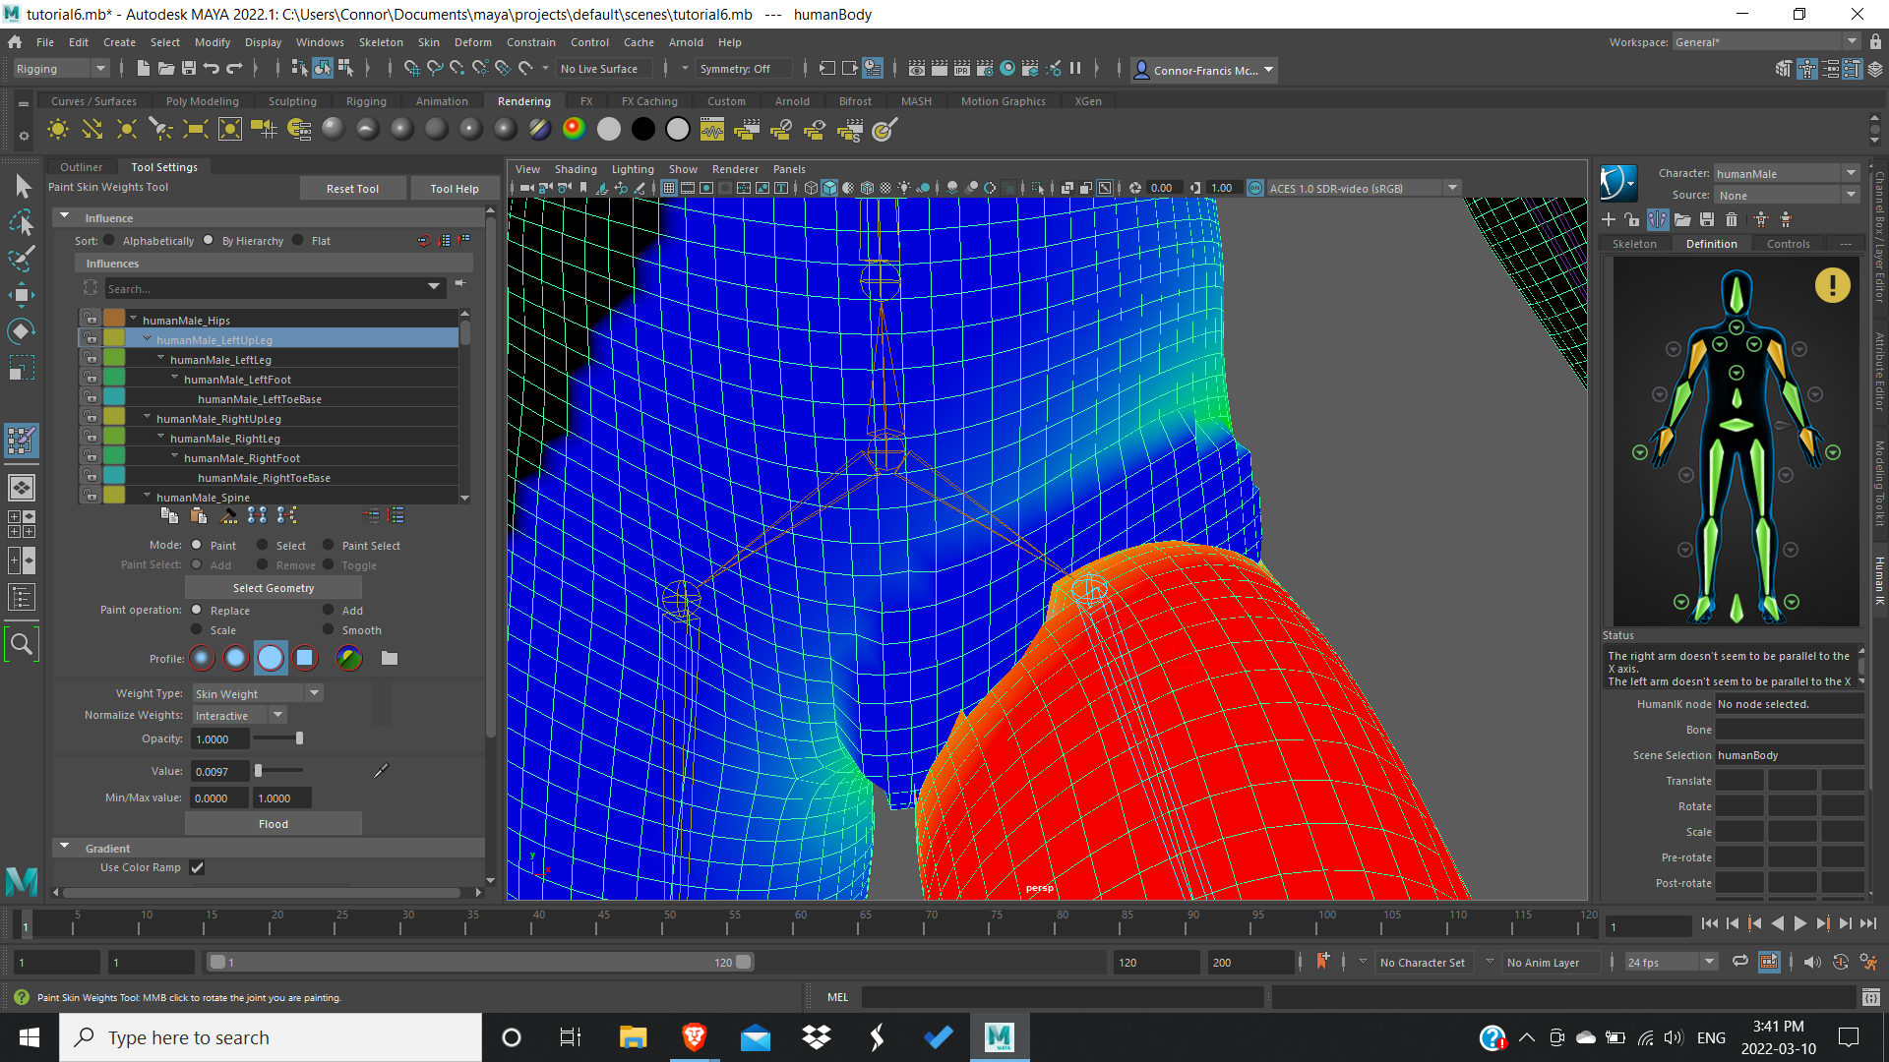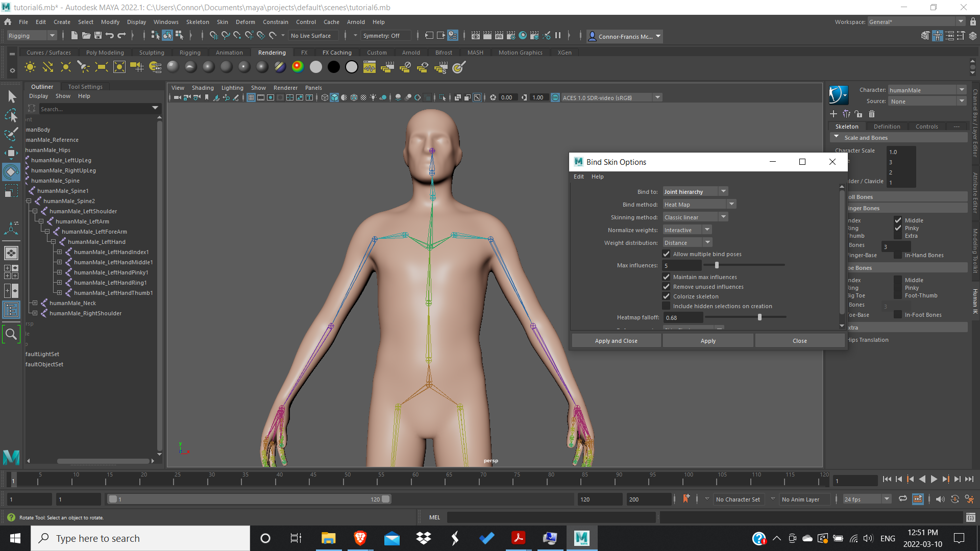

After the binding was done I went on to weight painting. Although it was not the longest process, it was the most difficult part of the whole project. We were warned to look out for problem areas such as the shoulders and the thighs, making sure that the skin doesn’t pull on unrelated parts of the body and is able to fold nicely on itself. Because I have such little experience I had a hard time judging whether or not something looked right. Even when I was watching the tutorials and was shown an example of good weight painting, I had trouble seeing why.

The shoulders were the part of the body I spent the most time on, making sure it only pulls the relevant chest muscles and doesn’t pinch the skin when they get lifted. It was a lot of trial and error, replacing areas so that I could pull them out and aggressively smoothing them over.

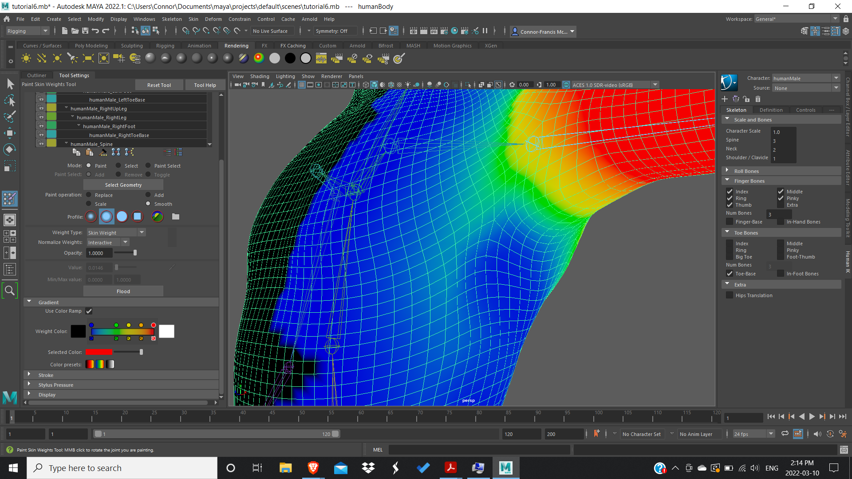

Being a symmetrical model, I weight painted one side and mirrored it over. This proved problematic as when I mirrored it for whatever reason it created areas with a lot of weight in the middle of the shoulders that pulled the mesh open when I tried to put the rig in T-Pose. I went back and checked every joint again and adjusted the weight painting from there.

After I fixed the weight painting I created the IK and FK handles.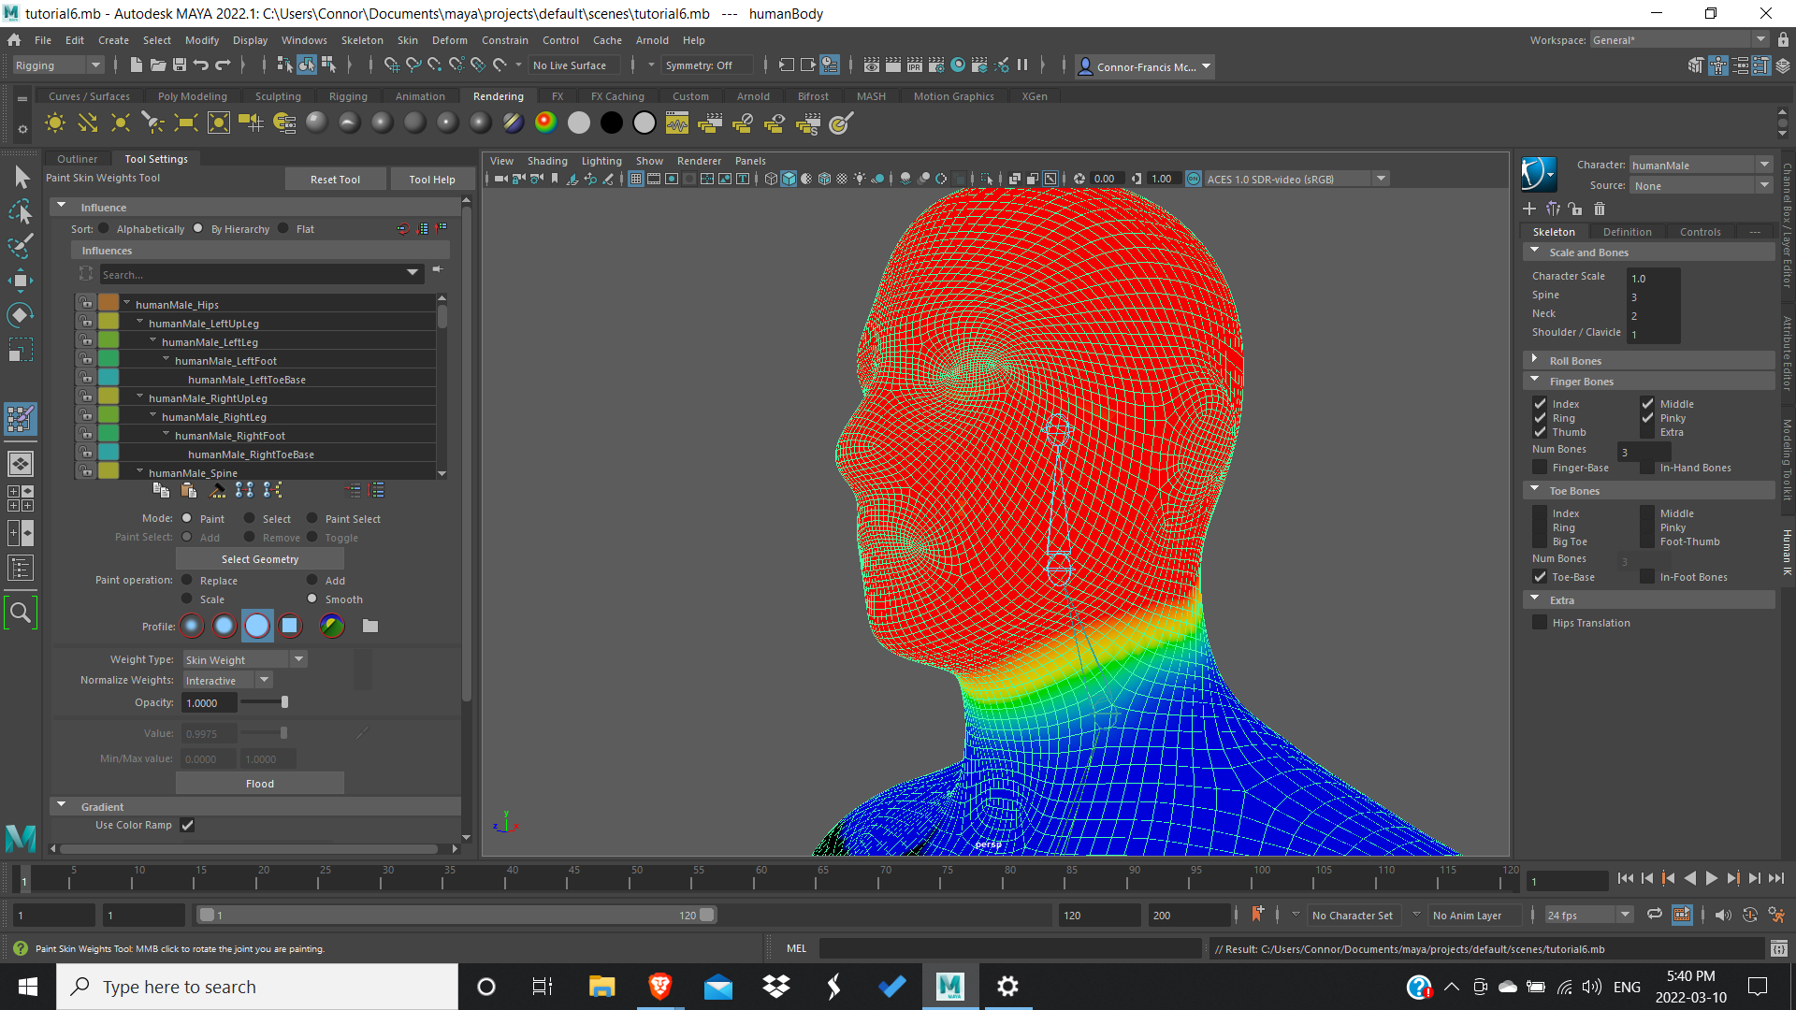

Then came the animation process itself. I underestimated how much keyframing this dance would entail. This dance is very fast paced and has many changes in direction, each change in direction warranting its own keyframe.

One thing I noticed immediately were the arcs. Every part of the body during this dance sequence moves in an arc. The feet, ankles, knees, hips, and arms all have an arc of motion. It was paramount that I nail this part of the animation and this is what gives its organic feel. Not only that, the quick pace, along with the smooth, non-mechanical movements help give character to the animation. Without even knowing the singer this was based on, someone could tell that he is agile and a proficient dancer.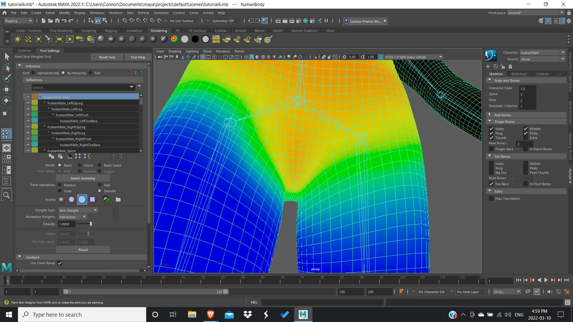

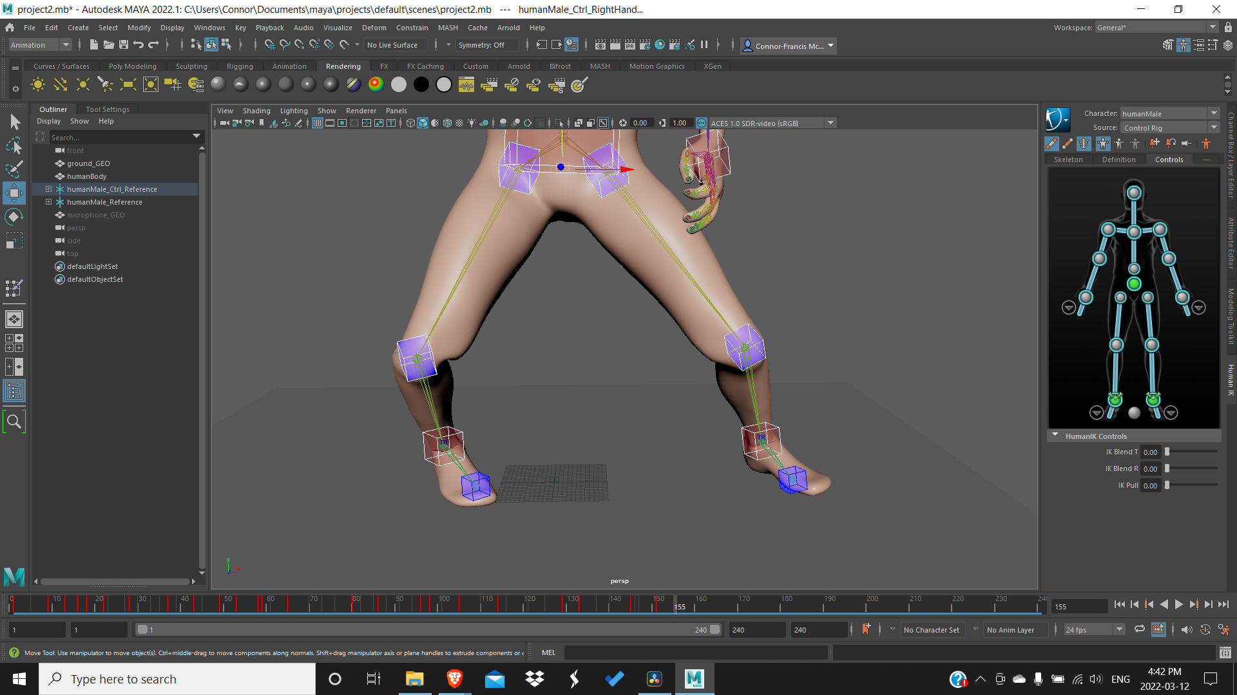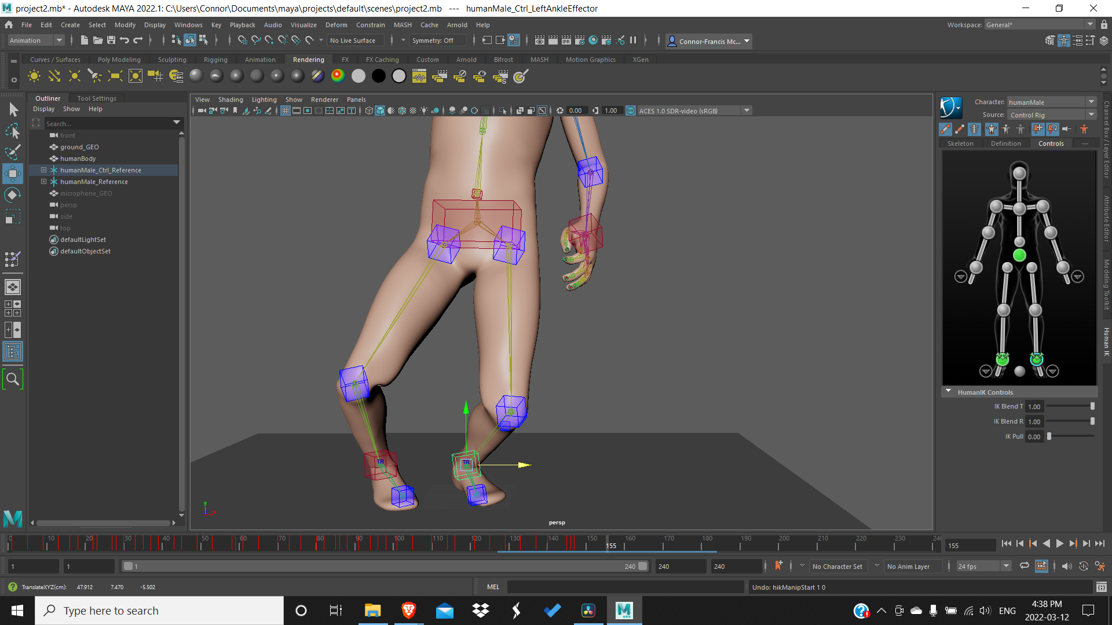

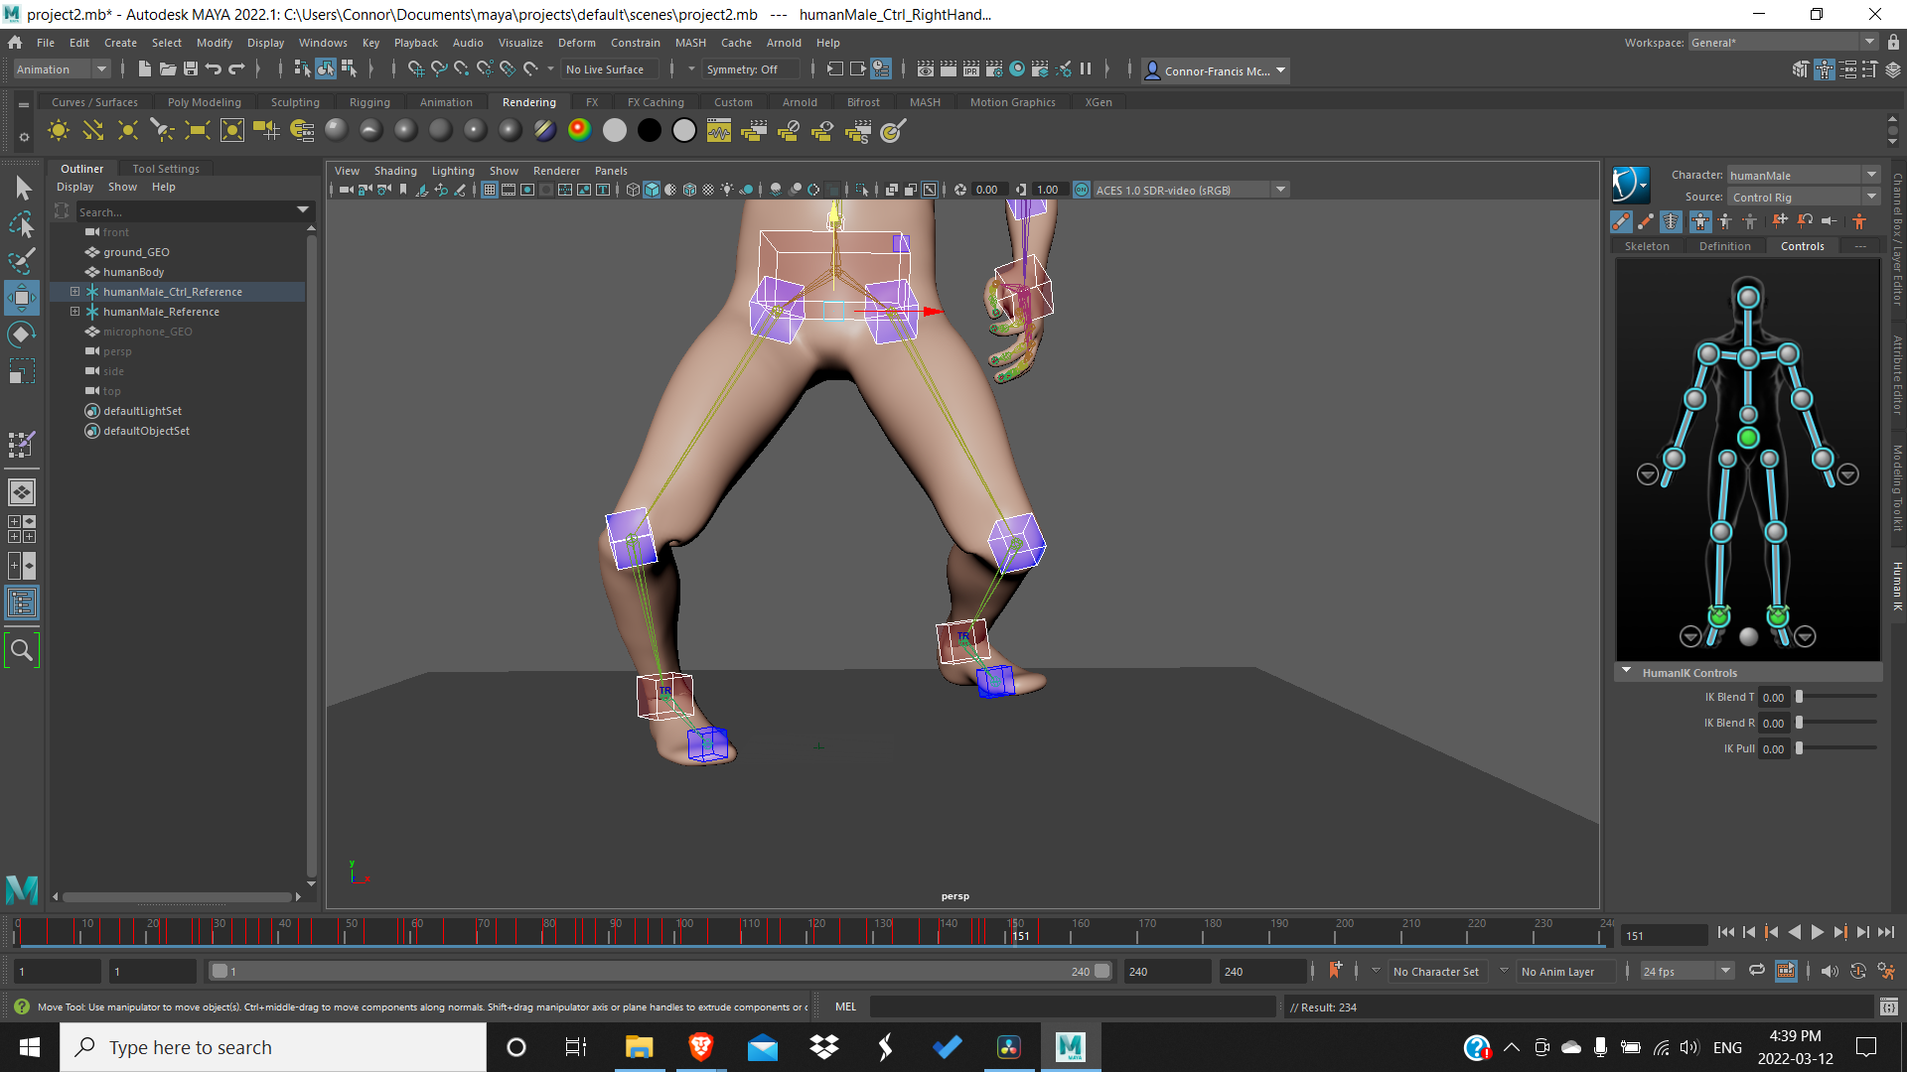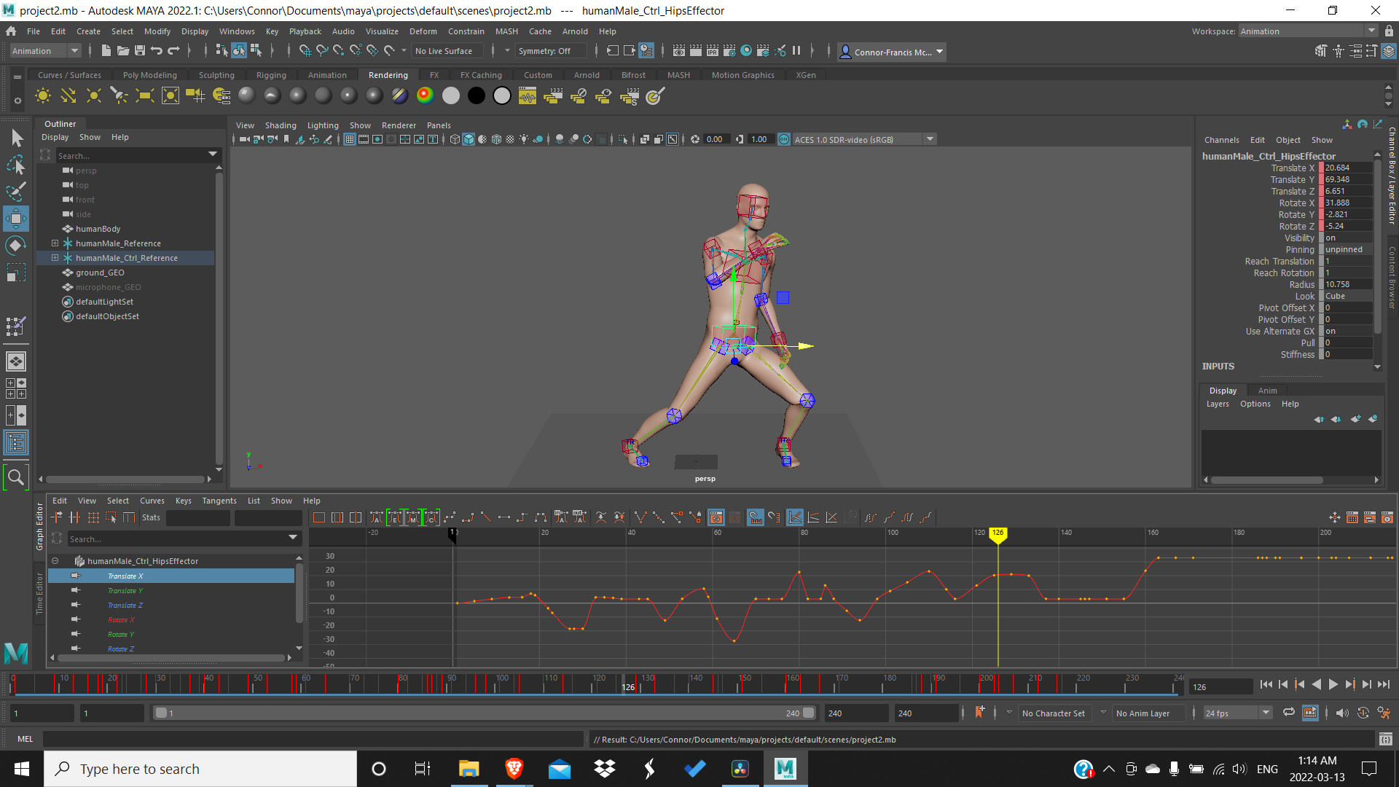

I animated these arcs using pose to pose, similar to project 1 (as depicted above in three photos). I accomplished this by first keyframing the start of the arc, shifting the IK handle horizontally, and then keyframing where it would land. After I did that I would keyframe the in between, shifting it vertically.

Due to how much the feet and ankles move I finished keyframed those first. In order to get the timing realistic, I tried my best to match the keyframes to the frames in the video.

I then focused on shifting the weight between legs by translating the hips on the x-axis in the graph editor. With the pins in place, I never had to worry about the feet sliding or going through the floor. This gives our character a sense of weight as it requires some effort to move this mass. I went into the graph editor and started editing the translation on the y-axis to work on the knee bends. I was also able to edit the handles on each keyframe so that the waist moved in an arc similar to the video. Finishing this made my animation look a lot less stiff, and made it look like the character was actually on a floor and not just floating in space. This also gave actions like jumping and landing a sense of anticipation leading up to them, and some recoil afterwards.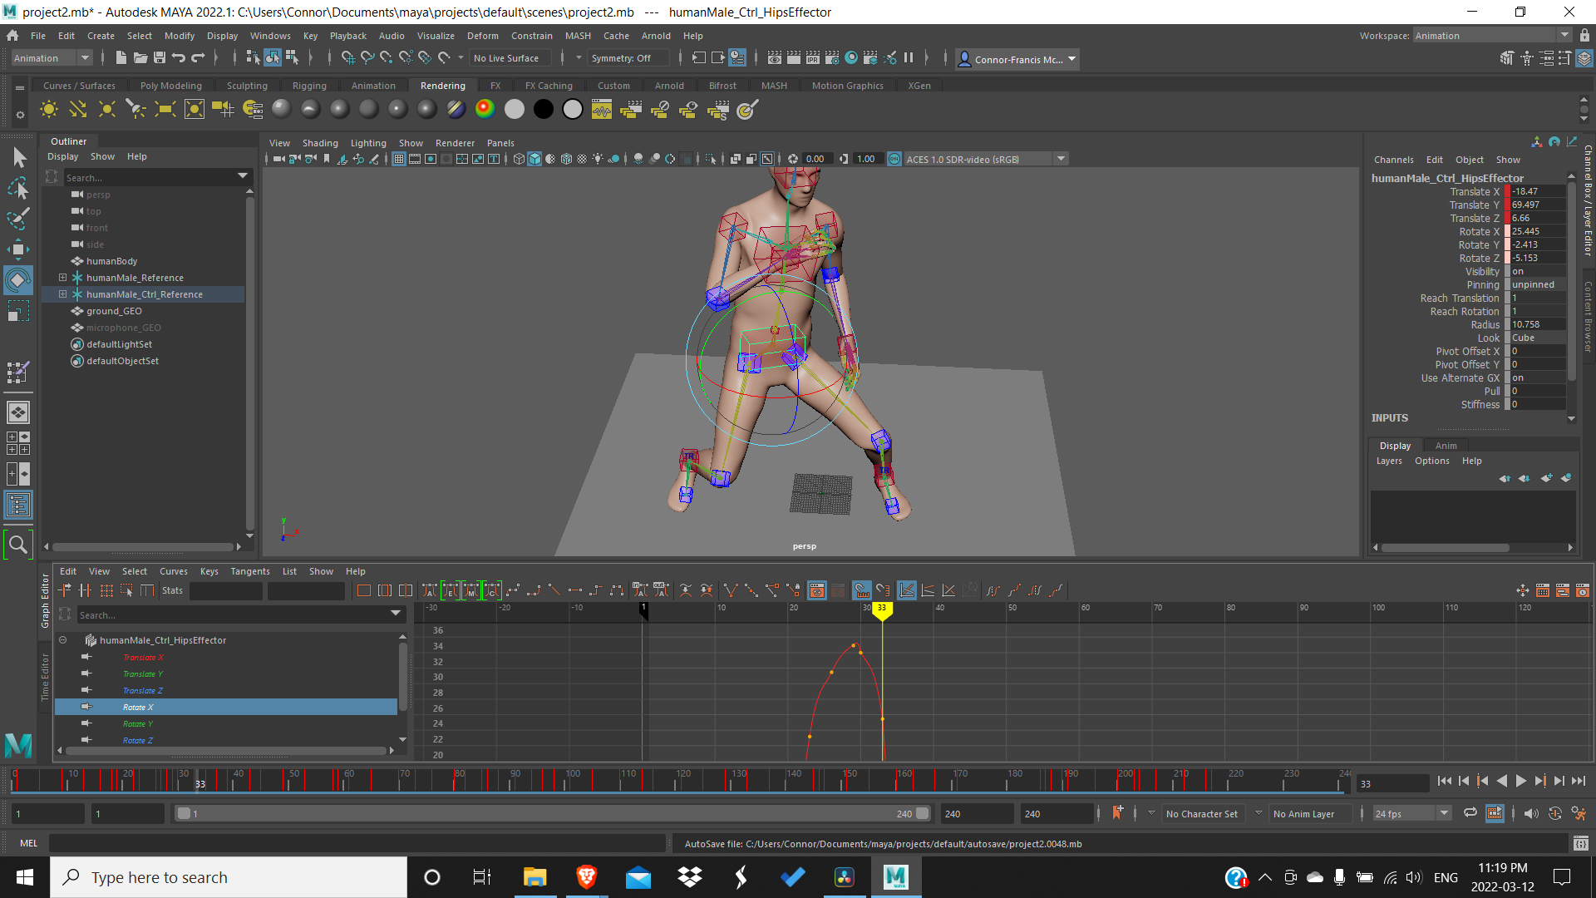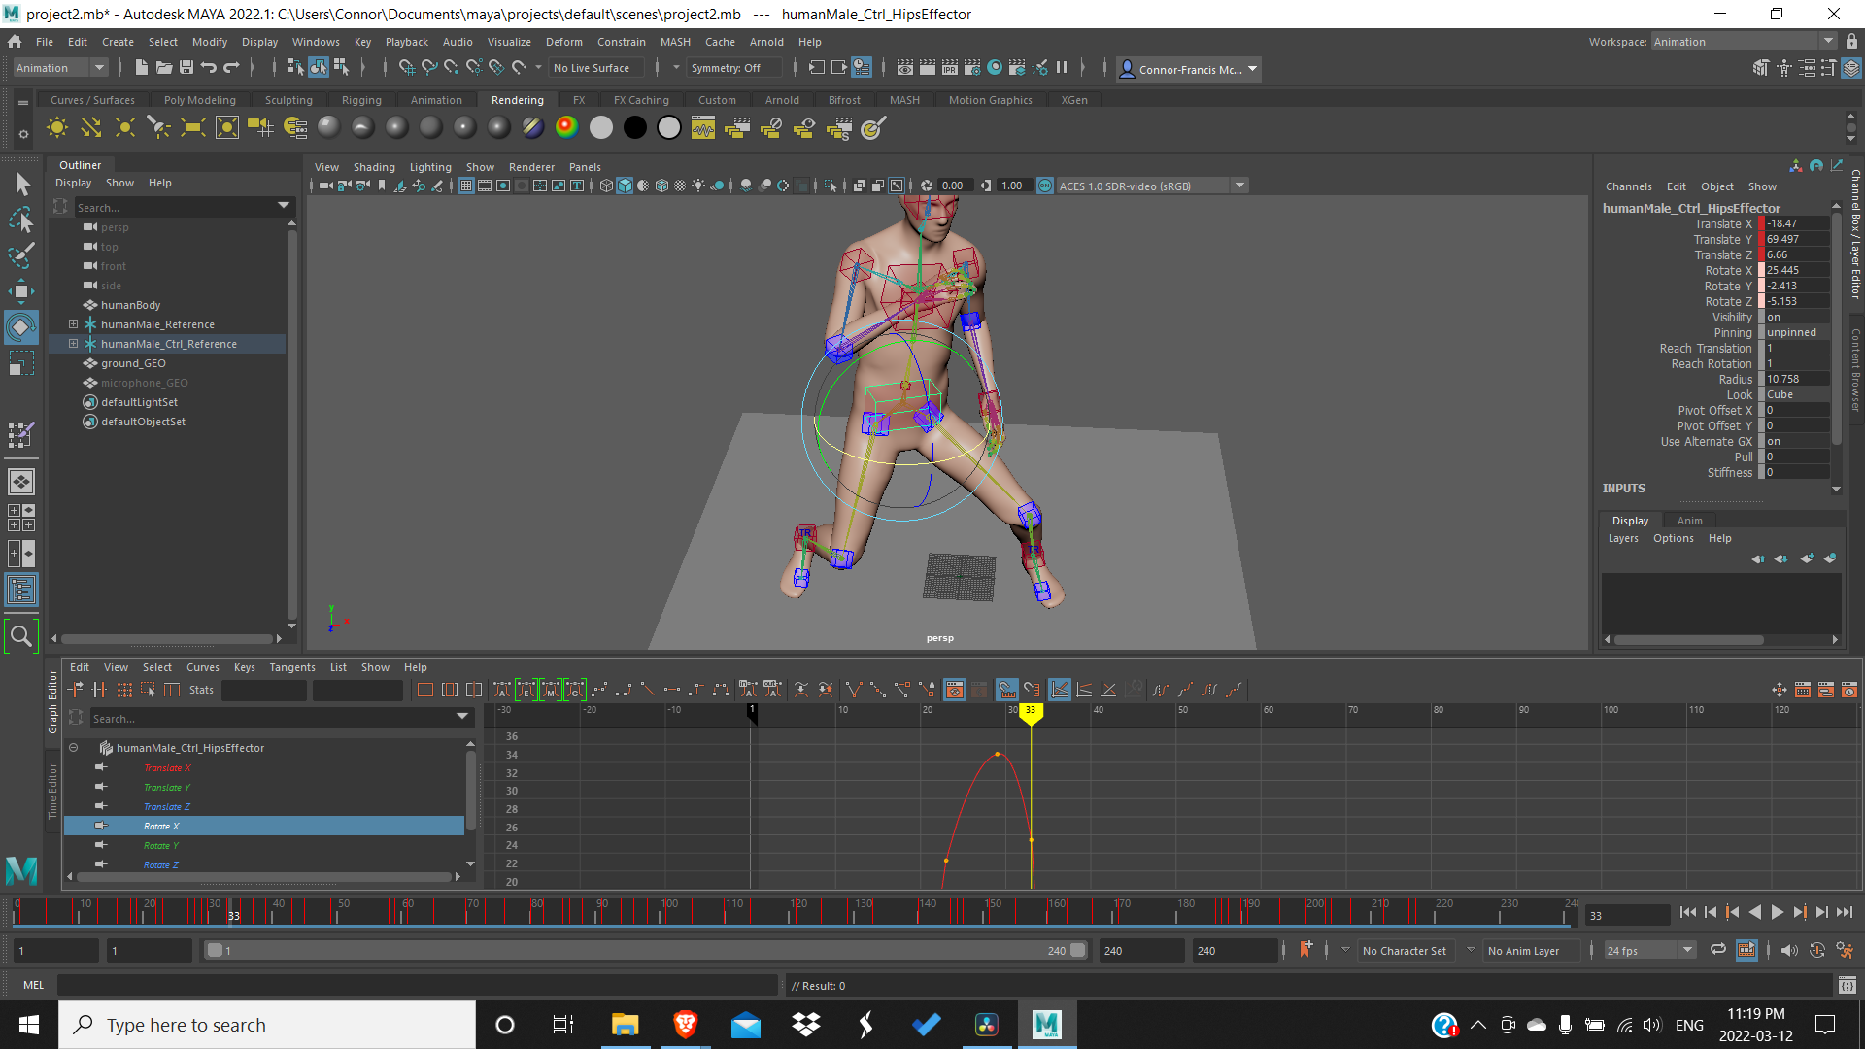

At this point I realized that even though keyframing the legs first made it quicker to animate the most difficult part, every time I changed the orientation of the hips in one frame, the next frame would snap back to its original position. Rectifying this was made easier through the graph editor.

When it came to rotating the hips, I made sure to add torque and counterbalance in the shoulders, looking in all of the views to make sure it looked correct from all angles.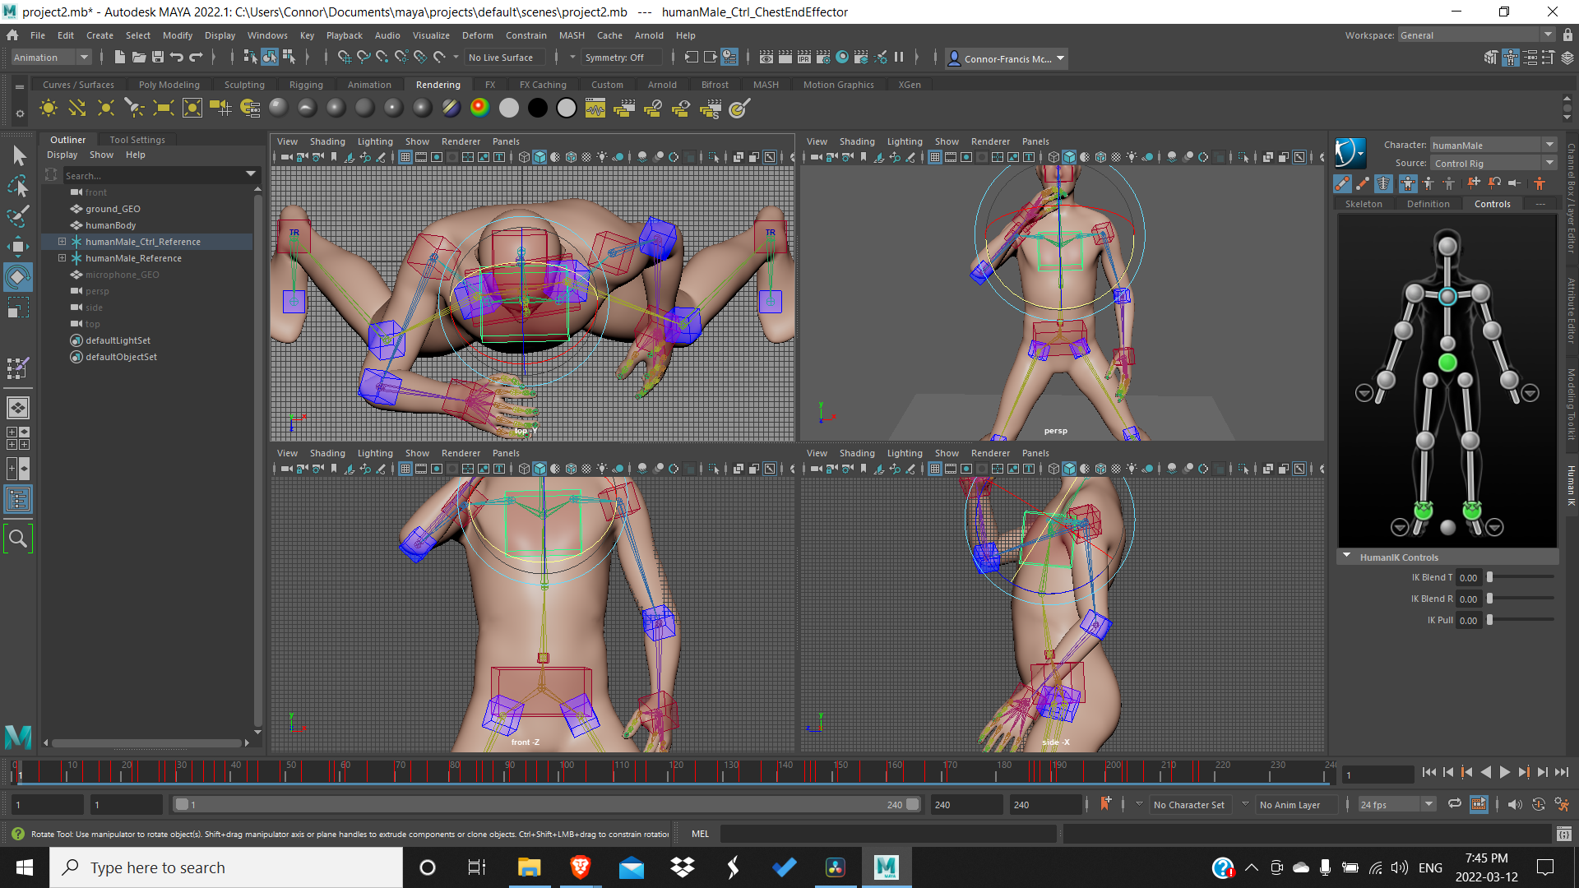

Once I had everything in place, I spent a long time tweaking everything in the graph editor to make it as smooth as possible. My biggest problem was the model moving in very jittery motions, most of the time I was able to solve this in the graph editor by deleting unnecessary key frames and dragging existing keyframes to different places on the graph, making the animation as a whole smoother.

Then from there I worked on the hands and arms. The left arm was held tightly by the singer, but still swung in an arc. The right arm was holding a microphone, and remained in the same position until the end. When keyframing the left arm I made sure to set it to body part mode so I don’t drag the whole body.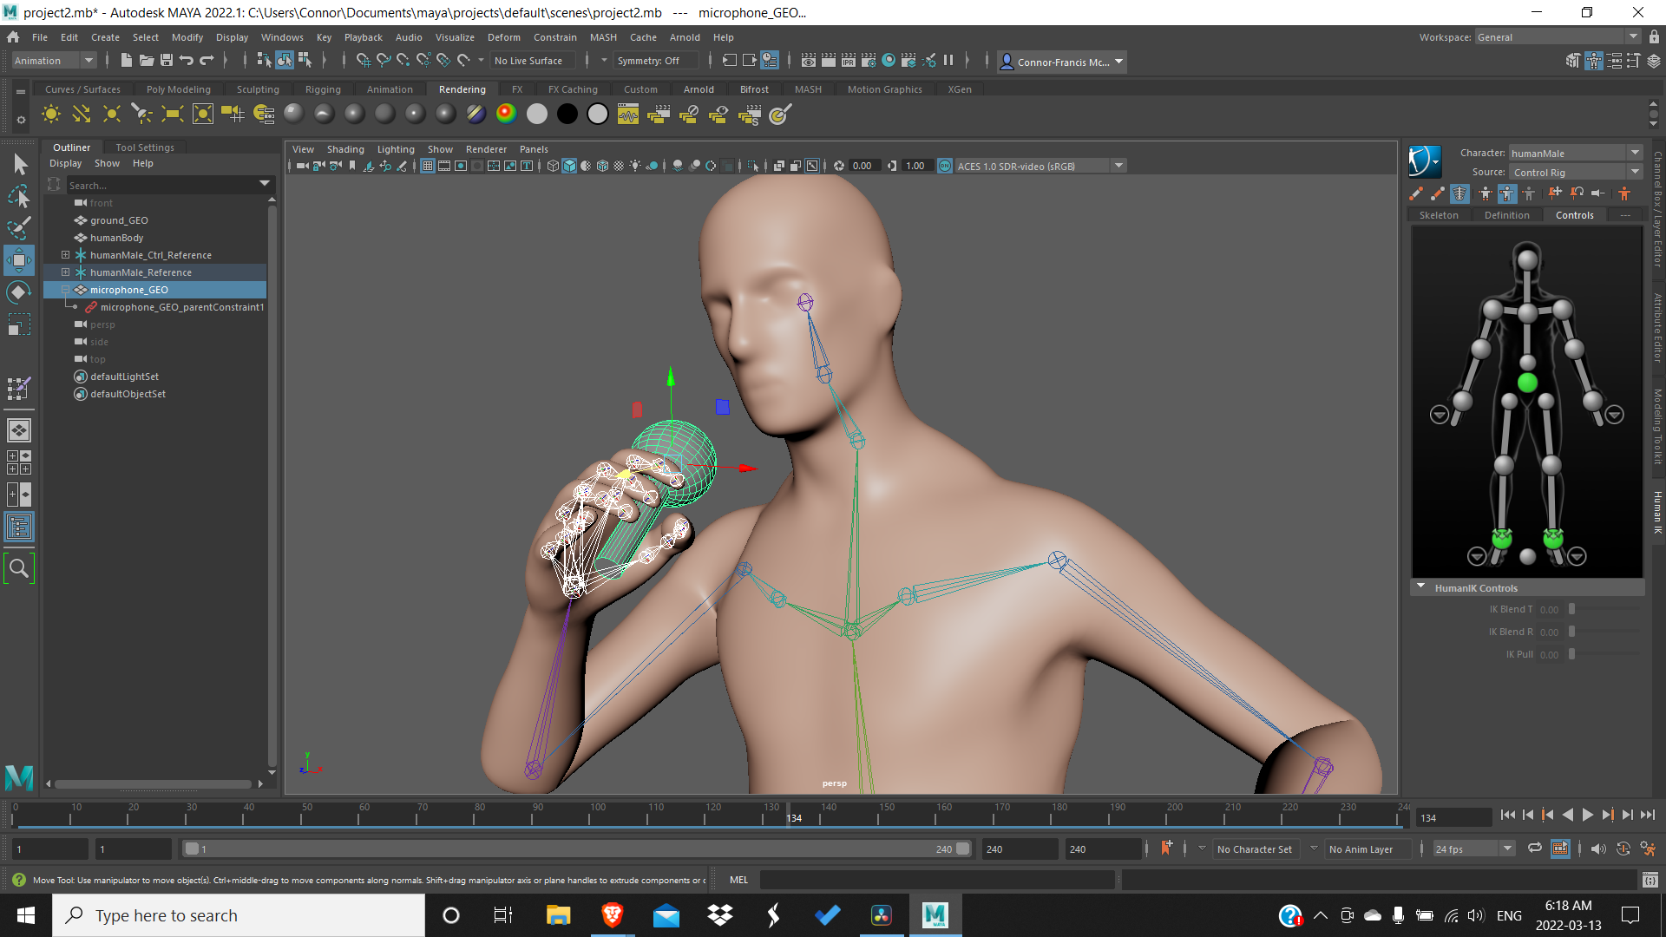

Then I created a basic microphone object and added a constraint to the hand so that it would stay in the same position the whole time.

I then put the rig and handles into a group so that I could translate it horizontally and vertically for jumping and sliding.